**Ideation Phase**

**Define the Problem Statements**

|  |  |
| --- | --- |
| Date | 06 May 2023 |
| Team ID | NM2023TMID14696 |
| Project Name | Smart city waste management system with connected trash cans |
| Maximum Marks | 2 Marks |

**Customer Problem Statement Template:**

Create a problem statement to understand your customer's point of view. The Customer Problem Statement template helps you focus on what matters to create experiences people will love.

A well-articulated customer problem statement allows you and your team to find the ideal solution for the challenges your customers face. Throughout the process, you’ll also be able to empathize with your customers, which helps you better understand how they perceive your product or service.

Reference:

**Example:**

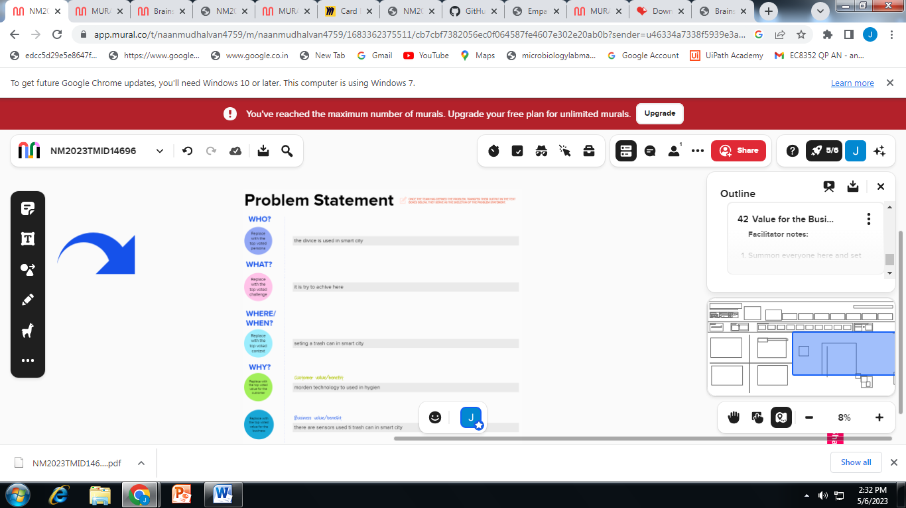

|  |  |  |  |  |  |
| --- | --- | --- | --- | --- | --- |
| **Problem Statement (PS)** | **I am (Customer)** | **I’m trying to** | **But** | **Because** | **Which makes me feel** |
| PS-1 | I want a good sensor to inform the cleaner | I am trying to make a smart city is a clean city | But I want a trash can at the distance of every 200 m | Because of the clean smart city | It feels like good |
| PS-2 | I want a good products and good gps | I am trying to make a diseases less city | Spearding of disease | For creat a awareness of diseases | It feels like happy people |